1.Start the scale
1.1 Please adjust the feet of scale ( has four feet on the bottom).
1.2Please switch on the power (the switch is on the bottom of scale). The scale will show the electric quantity “dc---4.41”on the total column and then return to zero in 3 seconds to ready for using.
1.3To make sure the scale shows zero. If not, press the key 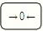 to return to zero. Please confirm that it indicates zero before weighing.
1.4Please warm the scale for 10 minutes before operation.
2.Price computing
2.1 Place the goods on the pan, the weight window will show the weight of goods
2.2 Price computing---Input the unit price of goods by numerical keys. For example, the unit price of orange is US$2.0 per kilogram. After input2.0,the total price window will show total price.
2.3 If input the wrong unit price, please press the key to delete the wrong unit price and then to input the correct figures again.
3.Tare 
3.1Place the outer package of goods on the pan and press the Key
3.2 Move away the package, then place the goods with package on the pan.
3.3 The weight window will show the net weight of goods after the scale is stable.
4.Accumulation 
If the goods wanted by customer are more than one, you may
press the key to get the total price of all the goods.
For example, the unit price of apple and banana are US$2.0/kg , US$4.0/kg respectively. If the customer wants each fruit one
kilogram respectively, please operate the following steps
4.1 After placing 1kg apple on the pan, you may input the unit price 2.0 by numerical key. Then press the key . The weight window will show “-Add-“ and the unit price window will show ‘1’ which means the first accumulation.
4.2 Move away the apple from the pan ,and place 1kg banana on the pan. Input the unit price 4.0 by pressing the numerical key while scale is stable. Then press the key . The weight window will show “-Add-” and the unit price window will show “2” which means the second accumulation.
RM
4.3 Press the key , the weight window will show
“”,unit price window will indicate “2” and total price window will show “6.00” which means the total price is 6.00
5.Clear the memory
Press the keyto clear accumulated record in the memory.
6.Add 
If your customer want to buy the other goods which price is known after you finished the above accumulation, you can use the key to add the price.
For example, your customer wants to buy a bottle of orange juice which price is 1.5 USD/PC. In this case, you may input the price 1.5 by numerical key, then press the key .
(At this moment, the weight window shows “-Add-“,the unit price window shows “3” ,and the total price window shows “7.50”. two seconds later, the all window show “0.00”.)
RM
Then press the key . the weight window will show
“”,unit price window will indicate “3” and total price window will show “7.50” which means the total price is 7.5 USD.
7.Recall
RM
Press the key to Review the each buying item record of the current customer, If you want to delete the record, press the key one by one.
MC
8.Change 
8.1 In the above case, if customer pay 10 US dollar, press the key ,then input 10.0.The total price window will show “2.50” which means the Money should give back to customer.
8.2 Press the key again to back to the price computing
mode. The above three accumulation will save in the memory unless you press the key to clear memory.
9. Backlight switch 
The backlight can be selected to be opened or closed by pressing the key If the backlight is on, the backlight will auto off while there is nothing operation over 10 seconds. But the backlight will auto on while you do operation again.
10.Alarm sign
While the ‘----------’ will be indicated in the weight window, which means overload this moment.
11.Recharge
11.1Please recharge the scale 8 hours before the first operation. It should be recharged under the state of shutdown.
11.2 Please recharge the scale in time when it shows low-voltage or the electric quantity shows “dc---3.90” on the total column.

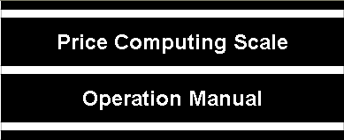
Notice:
Please recharge the scale before the first operation.

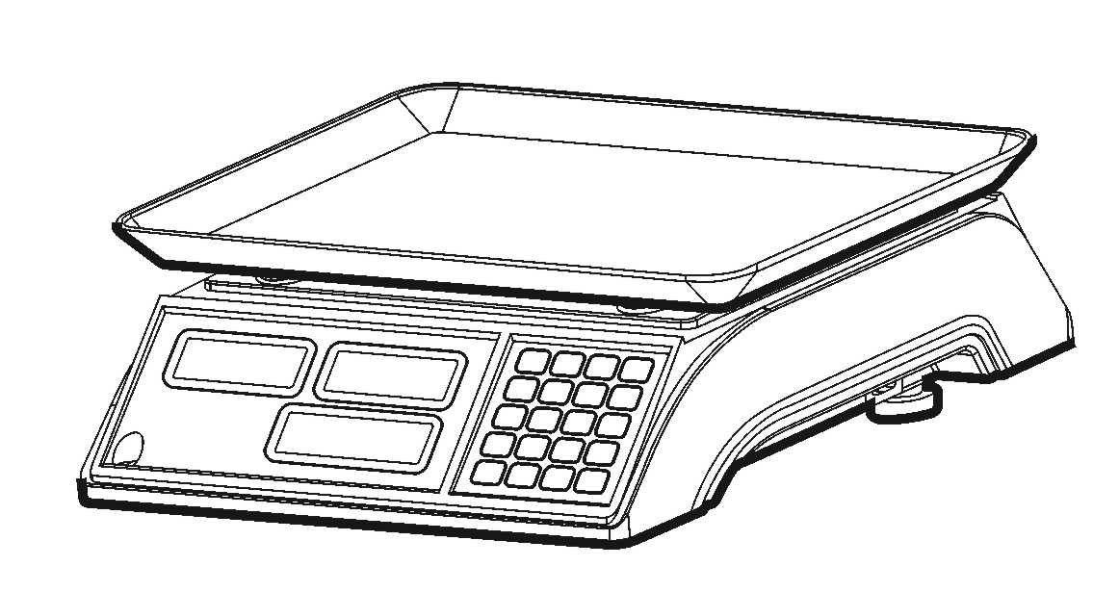

Specification:
Capacity | 3kg | 6kg | 15kg | 30kg
Division | 1g | 2g | 5g | 10g
Pan size | 285mm×240mm
Power source | AC:110/220V DC:4V/4Ah

