Electronic Price Computing Scale
Operation Manual

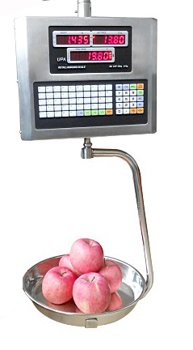

I. FEATURES:
- Dual-side LCD display (customer and vendor sides)
- Up to 1/7.500 display resolution
- Auto zero-point tracking
- Tare function
- Give-change function
- 50 pre-set memory keys (M1~M50) for saving unit price.
- Low power & charging status indication
- External digital-calibration
- Tube type 360° freely rotary hanger.
- 360° freely rotary supporting arm.
2. SPECIFICATIONS:
Model/Capacity | Model | Capacity | Division
Model/Capacity | UPA-T | 15kg/30kg | 5g/10g
Display | 5,5,6 digits, LED Display
Tare Range | 100% of full scale capacity
zero tracking range | ±3d
power-on zero range | ±3% FS
manual zero range | ±3% FS
Overload alarm | > max. Cap. + 9d
Calibration | External calibration
Pan size | 3600(d)*420(H)mm
Out line | 310(L)*250(H)*120(W)mm
Operating Environment | Temperature : 5 °C ~ 35 °C  Humidity: < 80%
Power Source | DC: 4Ah/4V Rechargeable Battery  AC: 110V or 220V ± 10%, 60Hz/50Hz
3. Function of Display and keypad
3-1 display
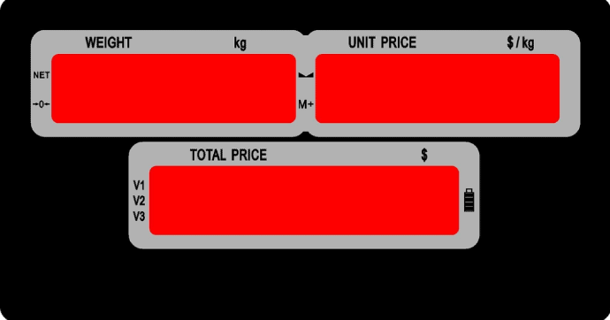
3-1-1 NET: when the light on, the scale in the mode of TARE.
3-1-2 : when the light on, the scale is in the zero.
3-1-3 : when the light on, the scale is stable
3-1-4 when the light on, means which customer is in trasction.
3-1-5 Low power & charging status indication
3-2 Function of keypad
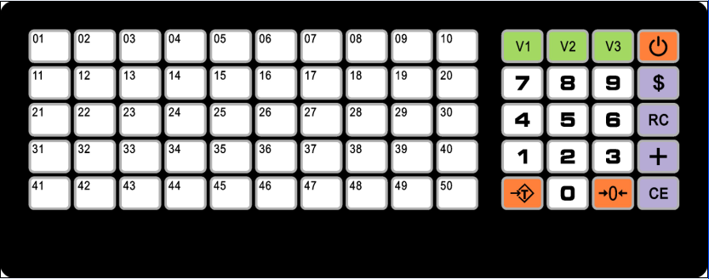

3-2-1: M1-M50, Unit price memory.
3-2-2:
3-2-3: : on/ off
3-2-4: : to give change.
3-2-5: : Review the finally accumulated record of the current customer
3-2-6: : to continue accumulating other non-weight-based items

3-2-7: : clear unit price;
3-2-8: : Tare
3-2-9: : Zero
3-2-10:1-0: numeric keys
4. Operation:
4-1.Start the scale
4-1-1 Use a M6 screw to fix the scale on the floor.
4-1-2 Press the key, the scale will return to zero in 3 seconds .Then finish the start.
4-1-3 To make sure if the scale shows zero. If not, press the key to return to zero. Please confirm that it indicates zero before weighting.
4-1-4 Please warm the scale for 10 minutes before operation in order to make more accurate.
4-2.Tare
4-2-1 Place the outer package of goods on the pan and press the Key
4-2-2 Move away the package, then place the goods with package on the pan.
4-2-3 The weight window will show the net weight of goods after the scale is stable.

4-3. Preset unit prices for weight-based items
a. Key in the unit price through numeric buttons while stable zero
b. Press the desired memory cell button and ”bi bi” sounds at the same time. Then the given unit price is stored.

4-4. Recall Preset unit price
Press the desired memory cell button (while zero point or loaded) and bi sounds. The unit price stored is recalled.

4-5. Price accumulation for weight-based items

a. Place an item on the pan while stable zero and give the unit price through numeric keys or recall from memory cell buttons (unit price will appear in the UNIT PRICE display),and total amount will be shown in the TOTAL PEICE display.

b. Press vendor # button (V1,V2 or V3) and “bi” accompanied, a V# LED light on the left-hand side of TOTAL display goes on.
WT. display UNIT PRICE display TOTAL PRICE
Display 01 ----------------------------- n --------------------------------- xxxxxx
No. of items already accumulated Amount already accumulated V# on-duty

c. Remove item from the pan, all the 3 displays will show ZERO, the vendor # LED light remains on.

d. Repeat step a~c to accumulate the amount of items bought by the same customer one by one

4-6. Price accumulation for non-weight-based items
a. Key in the subtotal amount of an item or some items through numeric keys while normal weighing status (the subtotal amount will appear in the UNIT PRICE display), Ex. 2 bottles of soy bean sauce (peso 1,200/bottle), 3 boxes of bagged coffee (peso 2,500/box) & 1 tube of toothpaste (peso 800/tube).You may press”+ ”button and then key in “10700” or press”+” button and key in “2,400”,then press “+” button again ,key in “7500”, then press “+” button and key in “800”.
b. Pressing “+” button to continue accumulating other non-weight-based items, and so on
c. Press V# button and “bi” sounds, the total amount for the above non-weight-based items is memorized and the display show the followings

UNIT PRICE TOTAL PRICE
n --------------------- xxxxx
V# on- duty subtotal for non-weight-based items

4-7. Functions of clear button (C key)

a. Press “C” button while in normal weighing mode to clear unit price keyed in or recalled from memory cell on the UNIT PRICE display.
b. Pressing “C” button also enables to clear the unit price & subtotal of non-weight-based items as mentioned in 4.
c. Pressing “C” button while in accumulation mode also enables to clear all the displays, but V# light will be still on and the subtotal of the current customer will be temporarily memorized.
d. Whenever a customer finishes shopping and pay exactly the total amount (i.e. no need to return change),keep pressing “C” button for 3 seconds to eliminate completely the transaction records of the current customer & end the operations (i.e. V# light on-duty goes off)

4-8. Review the finally accumulated record of the current customer

a. Press “ ＊ “ first and then press V# button (on-duty), the displays will show as below.

WEIGHT UNIT PRICE TOTAL PRICE
xx ------- n ------- xxxxx
Total item nos. weighed Total accumulated amount
Vendor # on-duty
4-9. Price accumulation for non-weight-based items

a. Key in the subtotal amount of an item or some items through numeric keys while normal weighing status (the subtotal amount will appear in the UNIT PRICE display), Ex. 2 bottles of soy bean sauce (peso 1,200/bottle), 3 boxes of bagged coffee (peso 2,500/box) & 1 tube of toothpaste (peso 800/tube).You may press ”+” button and then key in “10700” or press”+” button and key in “2,400”,then press “+” button again ,key in “7500”, then press “+” button and key in “800”.

b. Pressing “+” button to continue accumulating other non-weight-based items.

c. Press V# button and “bi” sounds, the total amount for the above non-weight items is memorized and the display show the followings

UNIT PRICE TOTAL PRICE
n --------------------- xxxxx
V# on- duty subtotal for non-weight-based items

4-10. Change
a. In the above case, if customer pay 10 US dollar, press the key ,then input 10.0 directly. The total price window will show “2.50” which means the Money should give back to customer.
b. Press the key again to back to the price computing mode. The above three accumulation will save in the memory unless you press the key to clear memory.

5. CALIBRATION AND SETTINGS
5-1 Internal settings
Turn on the scale, press the password: 3 2 1
Use the key “+” to chose, use the key “$” to confirm
1.Pnt | Decimal point
2.TrA | zero tracking range | 0.0; 0.5;1.0; 1.5; 2.0
3. LIt | Darkness of LED | 0; 1; 2; 3
5-2 Sealing arrangement: Calibration
Remove sealed cap and push the slide-switch to enter
Turn on the scale, it will display ”CAL-1”
Use V1 to choose division
Use V2 to choose decimal point
Use V3 to dual range
And then press “$” to confirm
Put the weight, input the number, 5000, and then press “$” to confirm and back to weighing mode.

6. Maintence
6-1 Alarm sign
While the ‘----------’ will be indicated in the weight window, which means overload this moment.
6-2 Recharge
1) Please recharging the scale over 8 hours at the first time before you use it. It is better to recharge under the state of shutdown.
2) When the battery electric quantity shows low battery, please plug in the scale to recharging.

