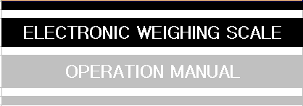
MODEL NO：UWA-D/ UWA-S

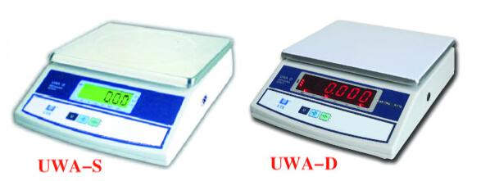
Note:
Please recharge the scale before first operation.
Please warm-up the scale over 5 minutes.

You have purchased a quality precision weighing instrument that requires handling with care. Read entire contents of this Operation Manual prior to operating your new instrument.

Disclaimer Notice
Calibrate your instrument using reference weights of the appropriate tolerance (class).
An instrument can be no more accurate than the standard to which it has been compared.
For assistance in the selection of reference weights, please contact the factory.
Caution: Changes or modifications not expressly approved by the manufacturer could void the user’s authority to operate this equipment.

Introduction
Thank you for choosing one of our instruments. Your instrument is designed and manufactured to the most rigorous standards in order to give you years of service. First, check the contents of the shipping carton. You should find the following:

*Manual *Instrument *Power cable

Next, follow the instructions for installing your instrument.
Now you are ready to begin using your instrument. To take advantage of its many features, carefully read your operating manual. It contains step-by-step procedures, examples, and other vital information.

Warning: Use of this product in a manner not specified by the manufacturer may impair any safety protection provided by the equipment.

-1-
Recharge
1. When to recharge
- After turning on the scale or in usage, the figures keep shinning, which means the power of battery is not full. It is time to recharge. If it needs to use, it may continue about ten hours.
When the message “Lo-bAT” appears, which indicate the power of battery is exhausted. Please turn off the power switch immediately and begin to recharge the battery to prolong its life.
2. Recharge Notes
It will take 6-8 hours to full the battery.

Maintenance
- Please take good care of the scale for it’s a precision
instrument.
- Place an object on the pan softly in less to destroy load cell
for the power of moment hit is too heavy.
- In order to keep the scale in formal; please recharge the
battery in time.

-6-
Calibration
F06-USr (Quick calibration)
When it displays
F6-USr

Press the key
P

It display
0.000
PUt

Put any STANDARD WEIGHT on the pan. After a little while,

It will display , press the key .
F6-USr
CE

The scale will finish calibration.

-5-

Specification
UWA-D/ UWA-S
Capacity | 3Kg | 6Kg | 15Kg | 30Kg
Division-A | 0.5g | 1g | 2g | 5g
Division-B | 0.2g | 0.5g | 1g | 2g
Division-C | 0.1g | 0.2g | 0.5g | 1g
Mini. Cap. | 10g/4g/2g | 20g/10g/4g | 40g/20g/10g | 100g/40g/20g
Pan size | 245 x 195 mm
Power | AC: 110V/220V; DC:4V 4Ah

Preparation

This product is intended for indoor use.
- Select a suitable work area.
- Work area should be relatively free from drafts and vibrations.
- Work surface should be level and rigid.
- Do not locate near magnetic materials or equipment/instruments which use magnets in their design.
- Avoid areas which have variations in room temperatures or have excessive room temperatures. Room temperatures above 40°C or 0°C could affect instrument operation and accuracy.

-2-

Function keys

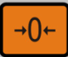 | Captures a new center of zero.
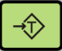 | Reduce gross weight on pan as tare weight.
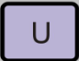 | Units convert key

Operation
- Getting Started
Turn the instrument on by pressing the power switch on.
The display will down count from 999999… while the unit is being updated.
Allow the unit to warm-up for 5 minutes.
- Taring (zeroing)
All models have taring (zeroing) capabilities up to their total weight capacity.
1. Place sample container on pan and then press the key, and will point to ->0<- on the display.
2. Now place sample in its container.
3. When the scale is stable, the display shows the weight of the sample.

-3-
Programme
Turn on the scale, and press the key ➔➔.The display will shows
F1-dIU

Press key for entering setting and confirm setting.
Press key for setting and goes to next step.
The programme sequence as follows:

Display | Option | Parameter
F1-dIU | Division | 1 2 5 10 20 50
F2-PNt | Decimal point | - 0.0 0.00 0.000 0.0000
F3-CAP | Capacity | If cap is 30kg, 30.000
F4-CAL | Calibration | only use for distributor
F5-trA | Zero-tracking | - 0.5 1.0 1.5 2.0  2.5 3.0 3.5 4.0
F6-USr | Quick calibration | See below
F7-LIt | Brightness | 0(weak) 1 (middle light) 2 (high light)
F8-bUd | Baud rate | 2400 4800 9600* 19200  （9600,for connect to printer and PC）
F9-odE | Print mode | 0 not print  1,3 press “P” to print  2 ,4 auto print when weighing  5 continuous print
FA-oFF | Auto turn off | 5 10 15 20 25 30 dis
Fb-ALr | Hi-low alarm range | In our off
FC-dNy | Animal function
Fd- UNt | Unit switch | ①：U1=kg U2=g U3=lb  ②：Def U1 on U2 on U3 off

-4-

