Electrical Balance/BB Series

Operation Manual
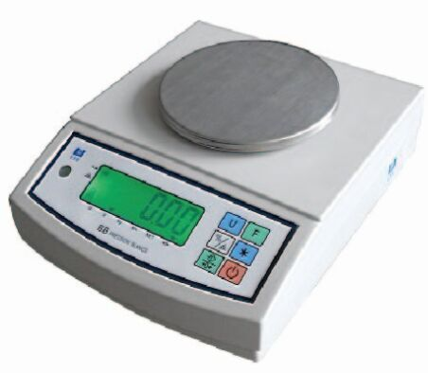

Specification
Capacity | 100g | 200g | 300g | 600g | 1200g
Division | 0.01g | 0.01g | 0.01g | 0.02g | 0.05g
Pan Size | ￠123mm
Power | AC voltage:110v/220v; DC voltage 4.5v(3 500mA cell)

Chapter 1 Functions and Specifications

1-1 Main function:
*Unit switching :gram, kilogram；
*Single screen simple counting function；
*Adopting high precision sensors,high precision 1/30000, accurate stable；
*LCD back-light and easy to read
*stainless steel scale clean easily
*RS232 interface which can connect to computer,printer etc equipment

1-2 Specification
Max. Capacity | 100g | 200g | 300g | 600g | 1200g
Division | 0.01g | 0.01g | 0.02g | 0.02g | 0.05g
Mini.Capacity | 1g | 1g | 1g | 2g | 4g
Accuracy class | Ⅲ
pan size | ￠123mm
Power | AC voltage:110v/220v; DC voltage 4.5v( 3 500mA cell)P.S.AC/AD can not be used at the same time

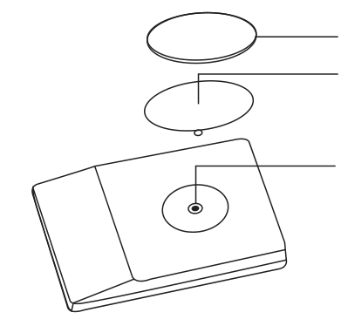
Chapter 2 Installation

- Stainless steel pan
- Screw M4*20 SB
- plastic pan (round)
- Use wrench to lock the screw after the plastic pan put on.
2.Then put on the stainless steel pan

Chapter 3 Display and keyboard
3-1 display
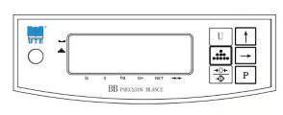

    - →0←(zero indication)–when ▼appears on the above position, said zero.

    - NET (net weight)- when ▼appears on the above position,said container
    - gross weight has been deducted .
    - (counting)- when ▼appears on the above position,said the quantity or percentage.
    - （stable）- when ▼appears on the above position,said weight in a stable state.

3-2 keyboard functions
:print function (available)
:for selecting various unit of weight
:return to zero and remove the peel key
:the parts unit and percentage key
:Choose the format of printing(used when connected to printers)
Under the state of weight,keep pressinguntil display no 01, then press  to choose the format of printing,then press to sure.

Chapter 4 operating instructions
4-1 Getting start
4-1-1 select a suitable work ares, make sure that the scale feet should level and under the state of no-wind.
4-1-2 turn on the power ,the scale will return to zero ,then finish the start.
4-1-3 make sure it is full of power or not.
4-1-4 make sure the cursor ▼point to or press the key to return to zero
4-2 counting function
4-2-1 take samples first(10,20,50,100 or 200,the more the better) on the pan,press ,the display will show 10,20,50,100,200 by cycle,press when it shows the quantity you put,the display will the quantity you put.Then put samples you want on the pan,it will show the quantity.
4-2-2 if want to know total weight ,press,again press return to counting state .
4-3 Calibration(this can be used after the operation FA-CAL)

Chapter 5 BB balance calibration and setting
When power turn on,self test.press three times，enter setting,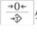 means select parameter,means confirm setting

.

Display | Option | Parameter
F1-diu | Division | 1 2 5 10 20 50
F2-Fnt | Decimal point | - 0.0 0.00 0.000  0.0000 0.00000
F3-CAP | Capacity | For example:300g,300.00
F4-CAL | Calibration | Please see attached 1
F5-tra | Zero-tracking | - 0.5 1.0 1.5 2.0  2.5 3.0 3.5 4.0
F6-USr | Calibration | Please see 4.3
F7-Lit | Back-light set | Au on off
F8-bud | Baud rate | 2400 4800 9600* 19200
F9-ode | Print mode | 1.manual 2.auto 3.continuous  4. ULP .manual  5. ULP auto
FA-unt | Unit switch  Open default unit set | U1(g) U2(kg) U3(1b) Def  U1 U2 U3f
Fb-ALr | high/low limit alarm set | IN OUT OFF

Attached 1
When show “F4-CAL”,
Press it will show CAL-1(if it show CAL-3 means 3 divisions calibration,can press to select)
Press ,it will show 005.00,press to select parameter
Pressto sure,when show “put”,put on the calibration parameter,pressto sure,then finish the calibration.

Chapter 6 Recharge, Maintenance &Repair
6-1 Maintenance
6-1-1 Please take good care of the BB scale for it is a precision instrument
6-1-2 Place an object on the pan softly in less to destroy load cell for the power of moment hit is too heavy.
6-1-3 In order to keep the scale in formal, please recharge the battery in time
6-2 Repair
6-2-1 Please don’t open the scale without permission.
6-2-2 Please contact with maintenance-station directly when it doesn’t work

Chapter 7 Common fault and debug method

Common fault | solution
Can’t boot up | 1.battery no power  2.cell line virtual welding  3.display and AD board connection off
Can’t charge | 1.charging line virtual welding  2.diode virtual welding(D2-D7),resistance virtual welding (R8,R9)  3.triode broken (7808)  4.battery can’ t storage power
Keyboard problems | 1.keyboard broken  2.K\B stand bad contact or virtual welding  3.I\C broken
Display not clear and hyphenation | 1.LCD problems .short circuit  2.display chip short circuit  3.7150 triode broken
Weighing inaccurate | 1.electrostatic,wind and other environmental factors  2.scale on stable, four feet off balance  3.the stand slanted lead to load cell run into the shell

Chapter 8 spare parts list

Name | Quantity
Main board | 1
Display board | 1
Charger | 1
pan | 1
Frame | 1
Load cell | 1
Plastic shell | 1
instruction | 1

