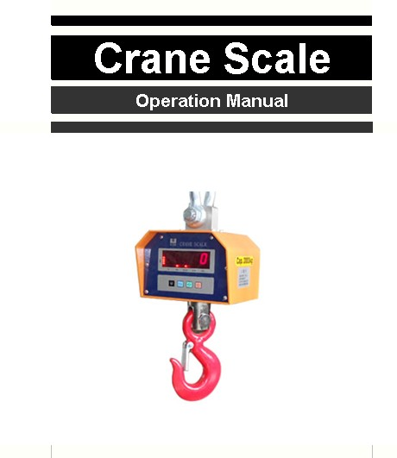

You have purchased a quality precision weighing instrument that requires handling with care. Read entire contents of this Operation Manual prior to operating your new instrument.

Disclaimer Notice
Calibrate your instrument using reference weights of the appropriate tolerance (class).
An instrument can be no more accurate than the standard to which it has been compared.
For assistance in the selection of reference weights, please contact the factory.

Caution: Changes or modifications not expressly approved
by the manufacturer could void the user’s authority to operate
this equipment.

Introduction
Thank you for choosing one of our instruments. Your instrument is designed and manufactured to the most rigorous standards in order to give you years of service. First, check the contents of the shipping carton. You should find the following:
*Manual *Instrument *AC Adapter *Remote Controller
Next, follow the instructions for installing your instrument.
Now you are ready to begin using your instrument. To take advantage of its many features, carefully read your operating manual.

-1-
Recharge
I. When to recharge
After turning on the scale or in usage, the figures keep shinning, which means the power of battery is not full. It is time to recharge. If it need to use, it may continue about ten hours.

When the message “Lo-bA” appears, which indicate the power of battery is exhausted. Please turn off the power switch immediately and begin to recharge the battery to prolong its life.

II. Recharge Notes
The scale has charger itself. Please use the charger to ensure
the safety, don’t use any other specification chargers.

When you use charger to charge the scale, the charging light keeps moving. When the light stops moving, the power is full.

It takes 6 hours to full the battery. The work time of battery is
30 hours.

Repair
Please don’t open the scale without permission.
Please contact with maintenance-station directly when it doesn’t work

-6-
Calibration:

Press the key  to start the scale. promptly press

the key 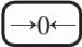 , , one by one. It will display [1-diu]

then press ”PEAK” until it shows [4-CAL],it means enter into the calibration.

1 Press the key 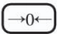 to show [00000].
Press the key to move cursor and press the key “PEAK” to set the value of calibration weight.

2 Press the key to show [put 1 x].
Now hang a the calibration weight on the hook.

3 Press the key to show [4-CAL].
Then restart the scale to finish calibration.

-5-
Illustration
Illustration of crane scale
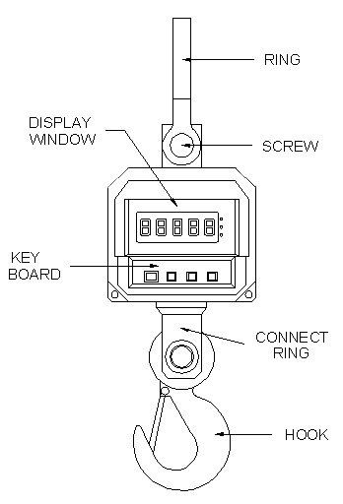

II. Illustration of remote-controller
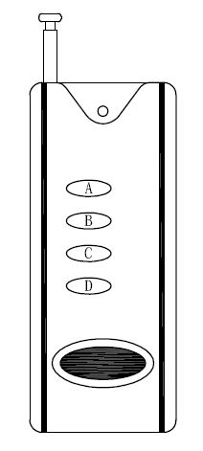
A：
B：

C：PEAK

D： U

-2-
Specification
Capacity | 600Kg | 1T | 1.5T | 2T | 3T | 5T
Division | 0.2Kg | 0.5Kg | 0.5Kg | 1Kg | 1Kg | 2Kg
Power source | AC: 110/220V, DC: 6V 4Ah
Operation Caution:
Do not stand or work under the scale.
Do not exceed the allowable loading capacity.
Operate by lifting the crane scale vertically to avoid risk of collision.
Installation
Remove instrument and accessories from the packing box.
Save packing material for transportation purposes.
If using the AC adapter, insert power cord into the receptacle
located on the side panel of the instrument. Firmly push in the
plug.
Allow the instrument to warm up for 30 minutes prior to use.
Your instrument features a numeric display that continuously
shows your weighing results.
Function keys
 | Turns instrument On or Off.
U | 1. Unit change.  2. Select the needed settings.
PEAK | To keep the value of weigh in the display.
 | Reduce gross weight on pan as tare Weight.

-3-

The program sequence as follows:

Display | Option | Parameter
1-diu | Division | 1 2 5 10 20 50
2-Fnt | Decimal point | - 0.0 0.00 0.000  0.0000 0.00000
3-CAP | Capacity | 3000～6000
4-CAL | Calibration
5-tra | Zero-  tracking | - 0.5 1.0 1.5  - 2.0  2.5 3.0 3.5 4.0
6-FLt | Filtration | 0～16
7-Lit | Backlight switch | 0 1 2
8-bud | Baud rate | 2400 4800 9600 19200

-4-

