ULP
THERMAL PRINTER
OPERATION MANUAL

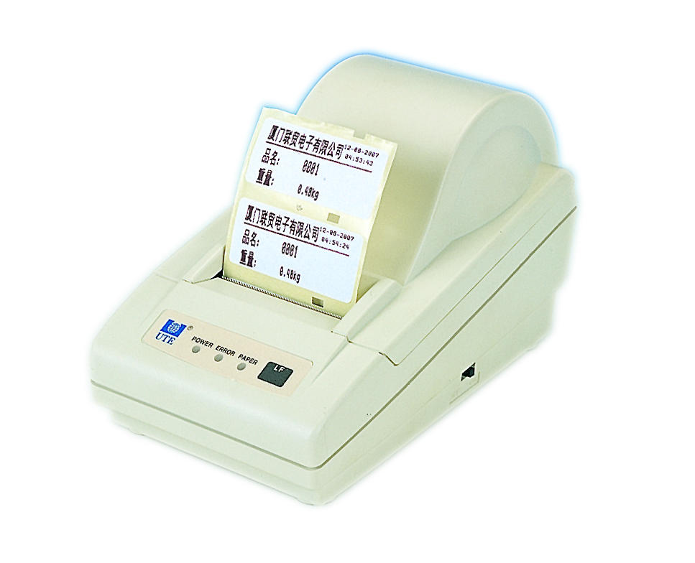

Edit 2008-05-01

CONTENTS:
1. BASIC RULES FOR OPERATING THE ULP--------------------1
2. Outer view – control ------------------------2
2.1. General description of the ULP
2.2. DIP switches and buttons
2.3. Indicators
2.4. Specifications
3. Detailed description of the software------------4
3.1. Install the software
3.2. Set the lable size
3.3. Working with text
3.4. Working with variables and counters
3.5. Working with barcode
3.6. Working with forms
3.7. Print
4. WORKING WITH UTE SCALES ------------------------------------18
4.1. BSC and UCA
4.2. BSWC and UWA print setting
4.3. BSWC
4.4. UCA
5．HOW TO GET A CORRECT TIME---------------------------------19

PACKING DETAILS:
- Printer -------------------------------- 1 SET
- Paper ---------------------------------1 ROLL
- Adapter ---------------------------------1 PC
- Software -------------------------------- 1 PC
- Manual -------------------------------- 1 PC
- Cable: printer to computer-------- 1 PC
- Cable: printer to scale --------------1 PC
1. BASIC RULES FOR OPERATING THE ULP

! FOLLOW INSTRUCTIONS CLOSELY
! MAY CAUSE DAMAGE TO THE UNIT

- The ULP is operated ONLY with its own DC adapter.
- Attempts to print on other types of paper, stickers, folio not specified as acceptable in this MANUAL may seriously damage your printer.
- When inserting the paper roll be careful not to let any pins, paper clips or other hard objects fall inside the printing mechanism.
- Do not spill liquids of any kind on the device.
- Print only on specified thermal paper-rolls.
- Don’t force paper out from the printing mechanism.
- Should the printer behave unusually during operation immediately turn it off!
- Printer repairs are performed only by service technicians. Do not attempt to repair the unit yourself.

ATTENTION! The printer operates with paper rolls with sizes:
- roll with labels: width 58 mm;
- maximum diameter of roll: 83 mm

-1-
2. Outer view – control

2.1. General description of the ULP
The ULP is a thermal printer designed to print small sized labels and graphics on thermo-sensitive paper. It is particularly useful when printing information, arranged in a template form, which has to be partially modified under customer demand.
The memory of the printer contains a command file which stores data for the arrangement and design of the separate graphic elements, easing your work considerably when you have to print a greater number of labels. The built-in 6 matrix fonts with different sizes, as well as the freely selectable option for additional scaling and rotation, gives you greater freedom in designing the inscriptions on your labels. If those fonts do not satisfy your requirements you are free to load additional fonts in the memory of the device.
The device may be used to print information from Windows (Word, Notepad or other programs) after the installation of the necessary driver.
In conclusion, the ULP offers fast and flexible printing at a quality which is very similar to that of most contemporary laser printers (printing density - 203 dpi).

2.2. DIP switches and buttons
2.3.1. Configuration switches
Sw1 | Sw2 | Sw3 | Baud rate (bps)
OFF | OFF | OFF | Local keyboard
ON | OFF | OFF | 2400
OFF | ON | OFF | 4800
ON | ON | OFF | 9600
OFF | OFF | ON | 19200
ON | OFF | ON | 38400
OFF | ON | ON | 57600
ON | ON | ON | 115200
 | OFF |  |  | ON
Sw4 | Hardware protocol |  |  | XON / XOFF protocol
Sw6 | Paper roll printing |  |  | Sticker label
Sw8 | Normal operation mode |  |  | -------------------------
-2-
2.2.2. Operation buttons
The FEED button extracts paper until it is released. In the “sticker type labels” mode positions the printing head over the next label.
ATTENTION! If you keep the button pressed when printer is switched off and switch it on in the meantime it will print out diagnostic information and then will enter the dump mode. After this operation the printer MUST be switched off and on again to return to normal mode!

2.3. Indicators:

POWER Lights in green when printer is ON.
ERROR Normally when printer is ON it is not active.
Blink in red when printer is overheated.
PAPER Off during normal printer status.
Lights in red when paper is over and blinks in red
if no label is found.

2.4. Specifications：
Print mode: thermal print.
Speed of print: 50mm/s
Sticker size: 57mm×25mm (1000 pcs /roll)
57mm×43mm (600 pcs /roll）
57mm×75mm (350 pcs /roll）
Life of printing head:70km
Interface：RS-232
Power: 12VDC/2.5A
Weight of printer：about 480g（without paper）
Work temp.：0— 50 ℃
Label Editor: design label by yourself
Available scale ：BSC，BSWC，UCA，UWA
-3-
3. Detailed description of thE SOFTWARE

3.1. Install the software

Put CD into the CD-ROM
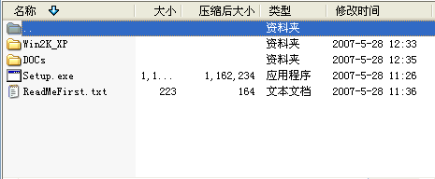
Click
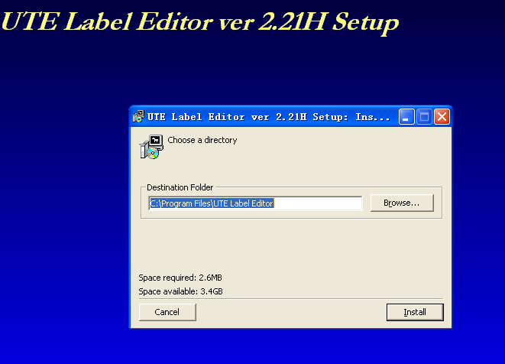

Press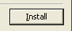to install.
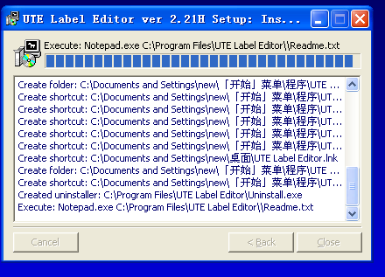
-4-
Then press 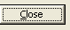to finish installation.

Then  will display on the windows desk.
Press twice into label editor.

3.2．Set the label size.
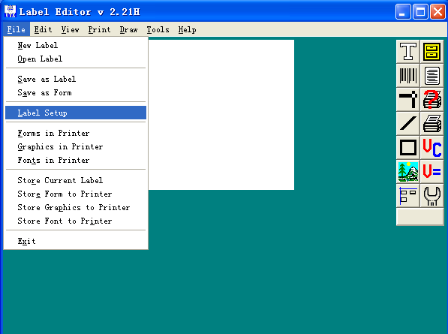

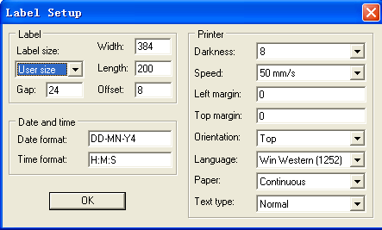

3.2.1. Setting date format

The command sets the mode in which the string will generate the current date.
Format: TDAxByC
With capital letter the fields for the date have been marked. A, B and C may have the following values, which may be used not more than once:

-5-
Y2 or Y4 The current year, marked with 2 or 4 digits.
ME or MN The current month shown in three letters or two digits.
DD The current day of the month.

The small letters mark the spaces between the fields. They are entered together with the symbol, which we wish to use. The divisors between the fields are marked in small letters - entered immediately after the symbols we wish to use.
Example:

DD-ME-Y4：This would generate a date of the type: 02-APR-2007
Y4-MN-DD：This would generate a date of the type: 2007-04-02

3.2.2. Setting time format
H: The current hour.
M: The current minute.
S: The current second.
The small letters are used to designate the spaces between the fields. They are entered immediately after the symbol, which we wish to use.
Example:H:M:S
This will generate a string of the type: 15:30:20.

3.3. Working with text：
Press ，
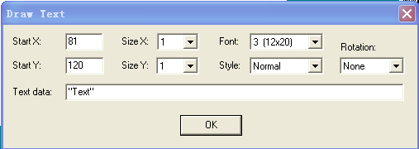

Start X : length to the left.
Start Y： length to the upper.
Size X： the size of the figure.
Size Y： the height of the character.

Font： There are six fonts to chose
0：12*24 dots
-6-
1： 8*12 dots
2：10*16 dots
3：12*20 dots
4：14*24 dots
5：32*48 dots
6：24*24 dots （only for Korean and Chinese）
Numbers, date, time, and English please choose 0-5
All words must in “ "

Example:

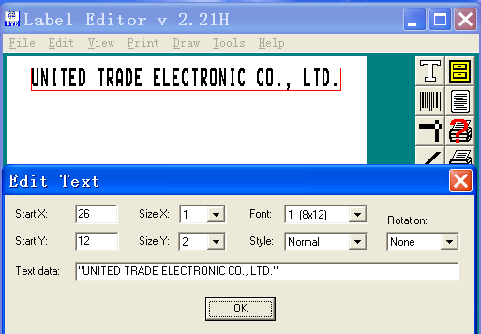

3.3.1. Setting date and time
Press ，

- Date code is TD
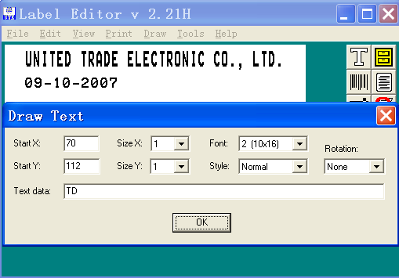

-7-
2.Time code is TT
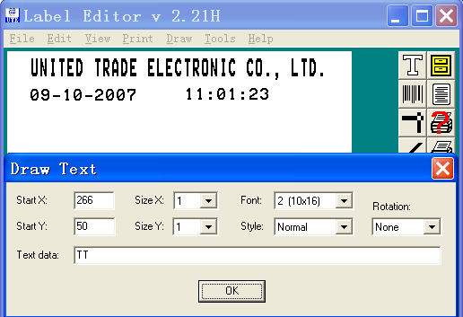
Note： 1）no need “ ".
2）Font must chose 0-5.
3）Must be in capital letter.

3.4. Working with variables and counters

Press
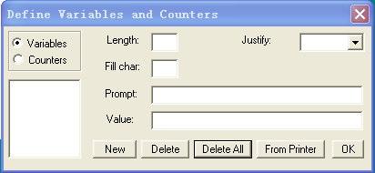
Press New to set variables：
Hear we provide UTE scales’ variables:

    - Counting scale: UCA and BSC:
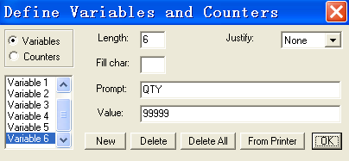
-8-
V0 25.40 (Gross weight)
V1 Kg / g (Unit)
V2 23.00 (Net weight)
V3 1.40 (Tare weight)
V4 0.12345 (piece weight)
V5 Kg / g (Unit of piece weight)
V6 999999 (quantity)
Example:
Gross weight is V0, Unit is V1，Press , put into V0V1, no need " ”

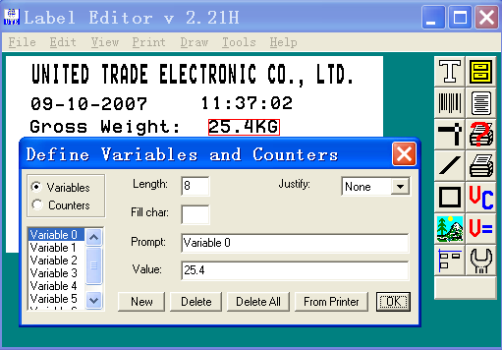
Net weight is V2, Unit is V1，Press, put into V2V1, no need " ”
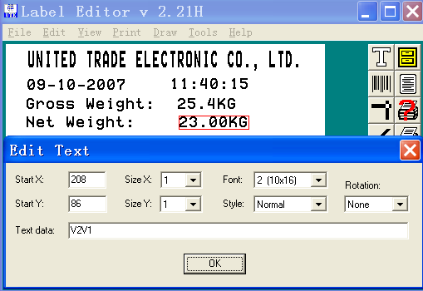
Tare weight is V3, Unit is V1，Press, put into V3V1, no need " ”

-9-

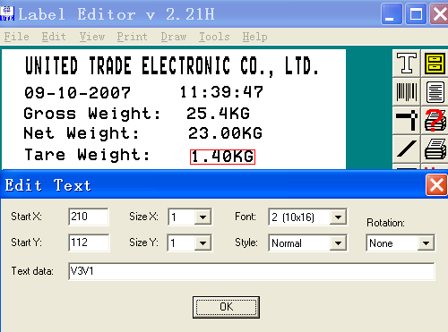

Quantity is V6, press, put into V6, no need " ”

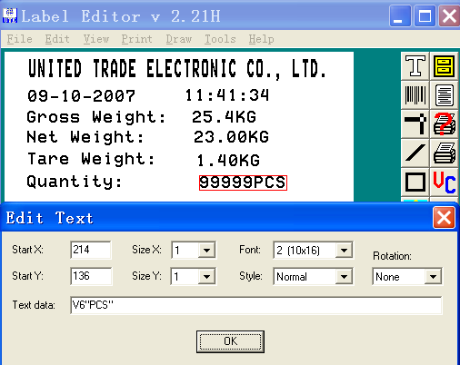

Now it generate a print formate as below:
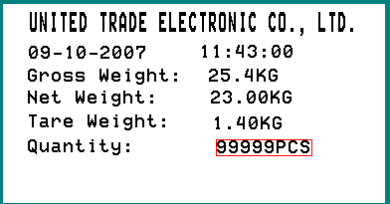
-10-

3.4.2. Weighing scale: UWA and BSWC:
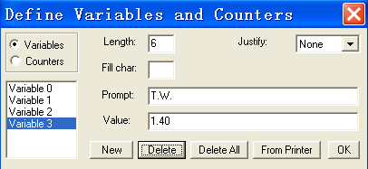
V0 25.40 (Gross weight)
V1 Kg / g (Unit)
V2 23.00 (Net weight)
V3 1.40 (Tare weight)
Gross weight is V0, Unit is V1，Press , put into V0V1, not need " ”

Net weight is V2, Unit is V1，Press , put into V2V1, not need " ”
-11-
Tare weight is V3, Unit is V1，Press, put into V3V1, not need " ”

Now it generate a print formate as below:

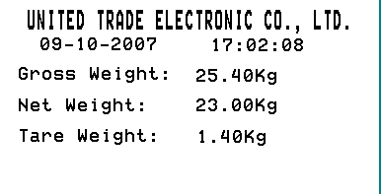

Defining a counter

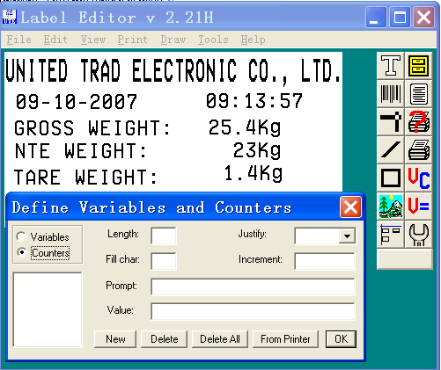
-12-
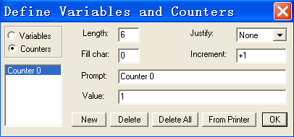
Press
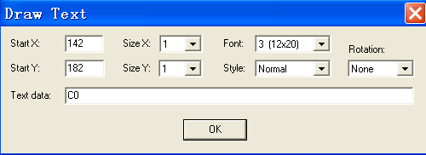
Now it generate a print formate as below:

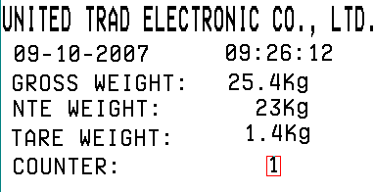
3.5. Working with Barcode:

There are some types of barcode for you to chose.
Table 1:
String | Bar code type
3 | Code 39
3C | Code 39 with check digit
9 | Code 93
0 | Code 128 UCC
1 | Code 128 auto A,B,C modes
K | Codabar
E80 | EAN8
E82 | EAN8 2 digit add-on
E85 | EAN8 5 digit add-on
E30 | EAN13
A30 | EAN13 with internal control digit
E32 | EAN13 2 digit add-on
E35 | EAN13 5 digit add-on
2G | German Post Code
2 | Interleaved 2 of 5 (ITF)
2C | Interleaved 2 of 5 with mod. 10 check digit
2D | Interleaved 2 of 5 with human readable check digit
P | Postnet
1E | UCC / EAN 128
UA0 | UPC A
UA2 | UPC A 2 digit add-on
UA5 | UPC A 5 digit add-on
UE0 | UPC E
UE2 | UPC E 2 digit add-on
UE5 | UPC E 5 digit add-on
2U | UPC interleaved 2 of 5
L | Plessey (MSI-1)

If the customer want the barcode can be changed as variables,e.g.:
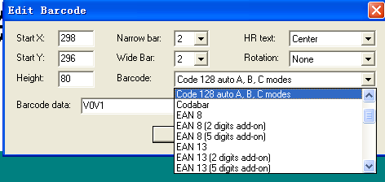

In the barcode text, you can put into V0V1, then the barcode can be changed as V0V1
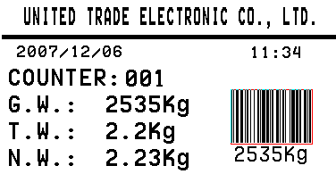
Now it generate a label as you need. You can test print it.

-14-
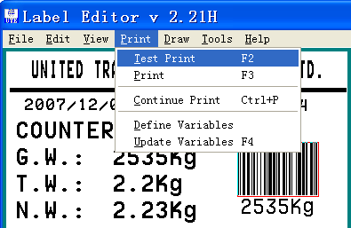
If the label is just what you need, now you start to store the label:

3.6. Working with Forms
3.6.1.Starting to save a new label
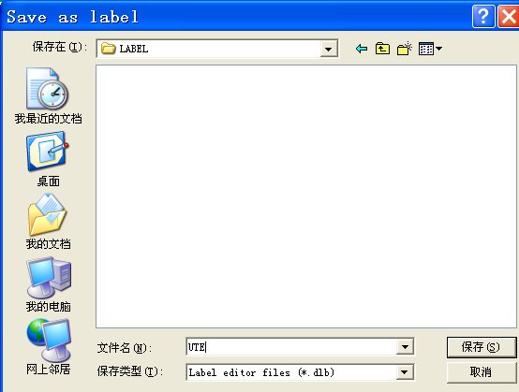

3.6.2. Starting to save a new form
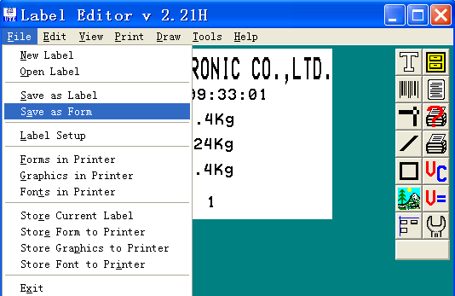

-15-
3.6.3. Store form to printer
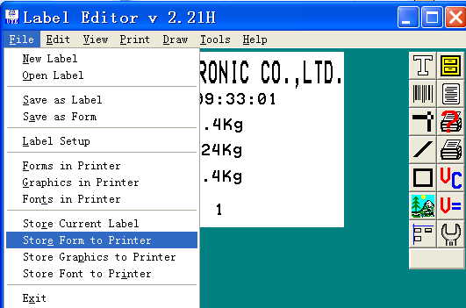

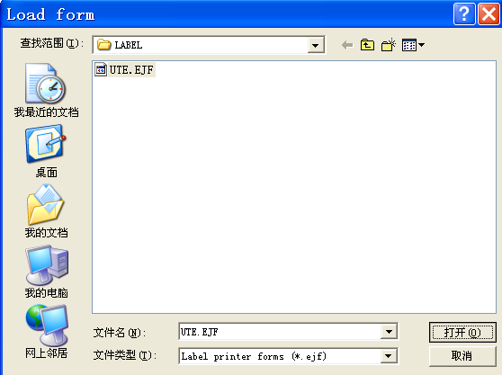

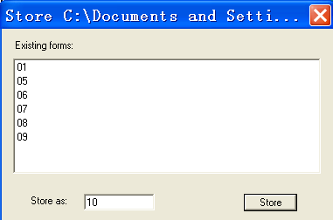
3.6.4.Loading a form from the printer

-16-
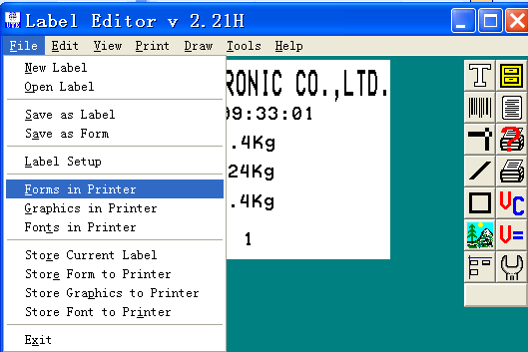

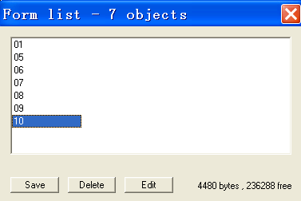

press , can edit the form.
After saving forms to printer, the scale can order it to print.

3.7. Print
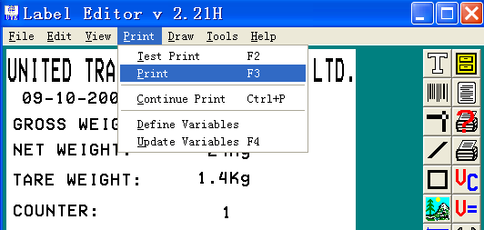

-17-
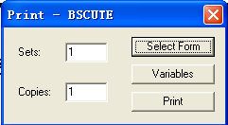

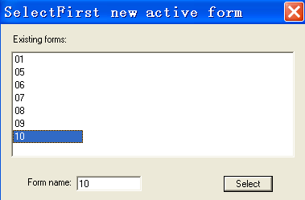

4. Working with UTE scale

4.1. BSC and UCA
Press “ F ” , and hold on for over 5 second. Enter into In.PAGE, putin the form number (0~99)，Press “ F ” again to quit. (If change form number,then counter will return back to 1).
When scale is stalbe, press “ F ”, then it will print the needed form.

  - BSWC and UWA print setting:

 | BSWC | UWA
Pr 0 | NONE | NONE
Pr 1 | 16S hand | ULP hand
Pr 2 | 16S auto | ULP auto
Pr 3 | 16S continue | 16S continue
Pr 4 | ULP hand | X
Pr 5 | ULP auto | X
-18-
    - BSWC
In the mode of weiging, press the key “ ”, the indicator display “NO.XX”, press the key “ ” to chosse needed form number. Then Press “ HI-LO” to confirm.
When scale is stalbe, press “HI-LO”, then it will print the needed form.
    - UWA
In the mode of weiging, press the key “ F ”, the indicator display “NO.XX”, press numberic keys to chosse needed form number. Then Press “ F” to confirm.
When scale is stalbe, press “PRINT”, then it will print the needed form.

5. How to get a correct time

Connect print to computer:

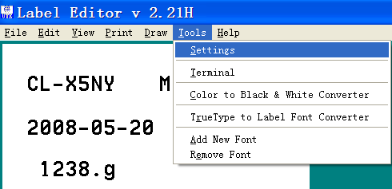

-19-
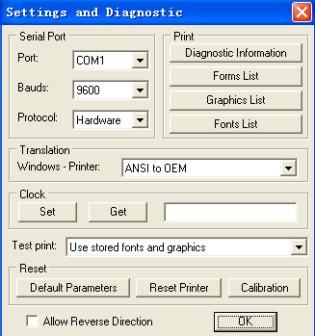

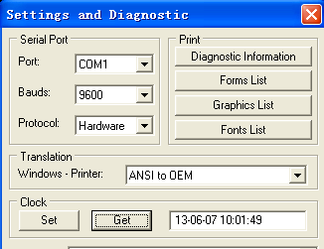

If the time is correct, press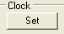 to confirm, and press to store the setting.

-20-

